How to share folder between windows server and client?
Lets continue from our setup.
I have already setup virtual network, domain controller user and client machine.
Both server and user are on same network as well as DHCP and DNS is already configured. I have also created users.
Lets get started,
First on server lets create a folder inside drive c,
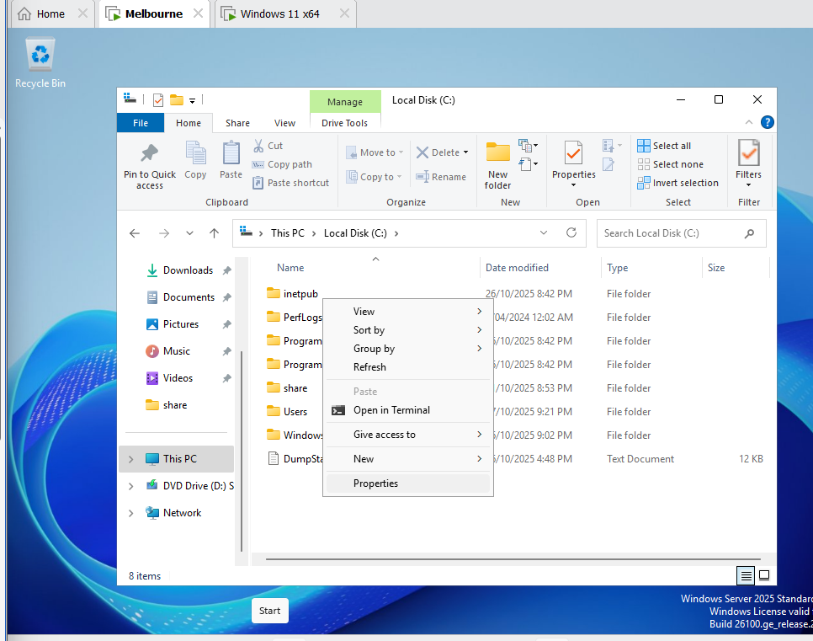
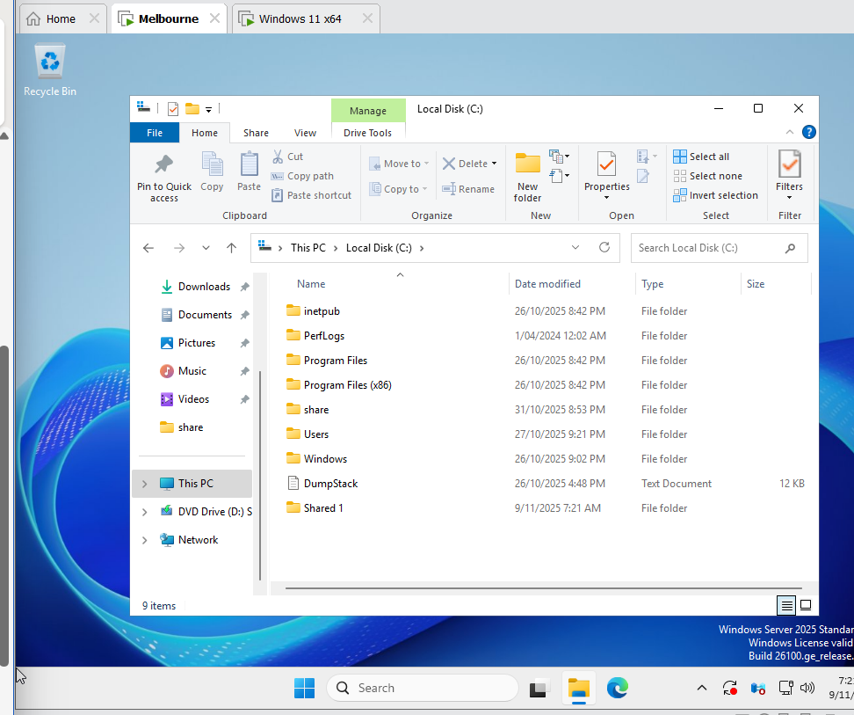
Here I created folder share and shared 1.
Then for sharing go to properties of the folder then on sharing,
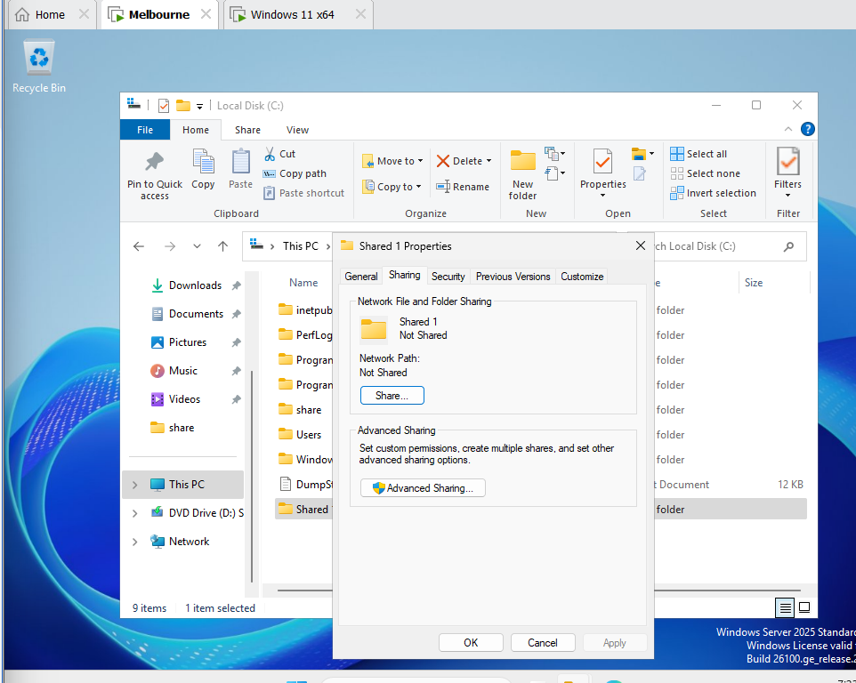
Go on sharing > advanced sharing
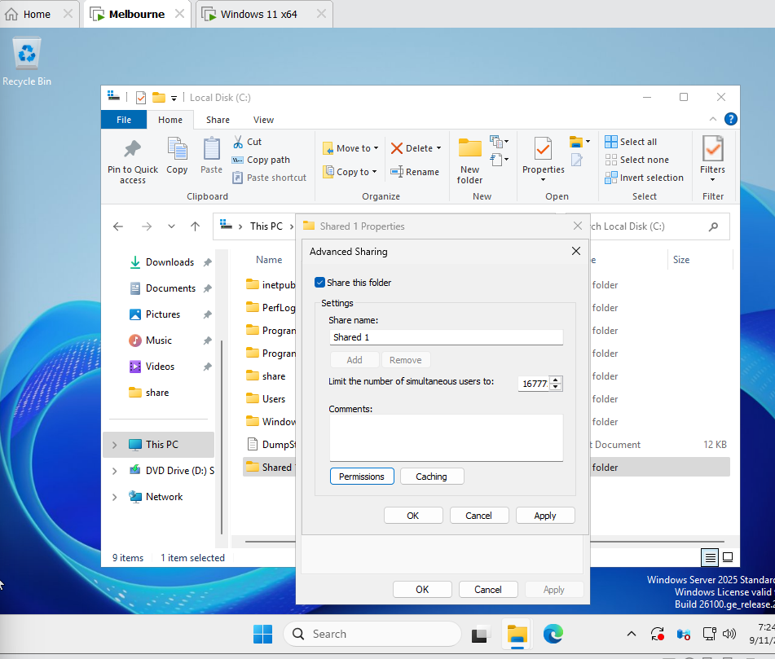
Then share this folder checked after that select permission and add user then apply and press ok,
You can also give the permission to read only read write and full control here I give full control to user lucky smith,
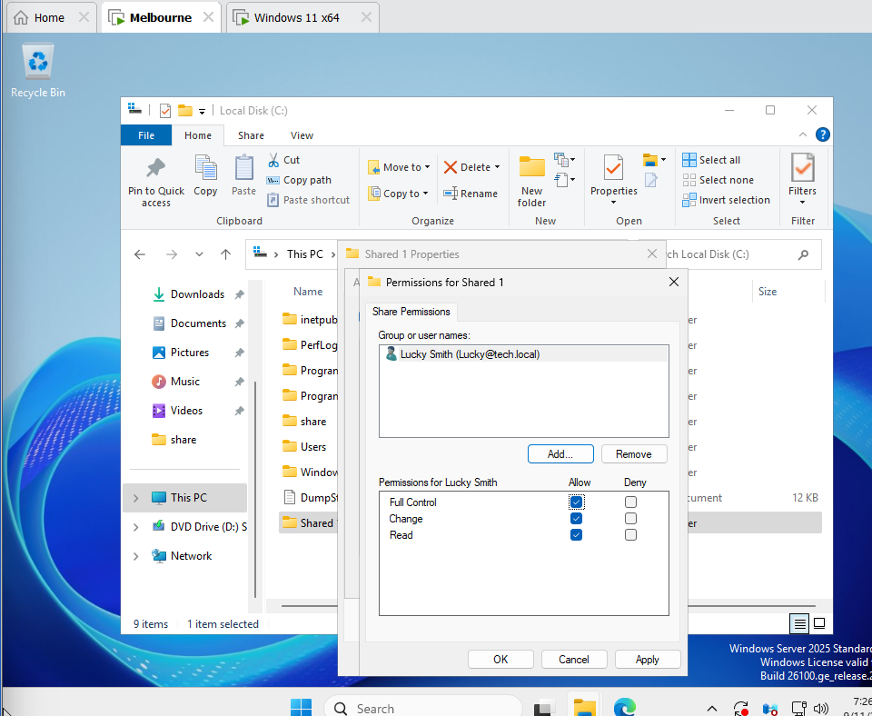
Now for sharing you need to turn on network sharing on both user and server,
Lets do it,
Go on properties of network on your file explorer of your device,
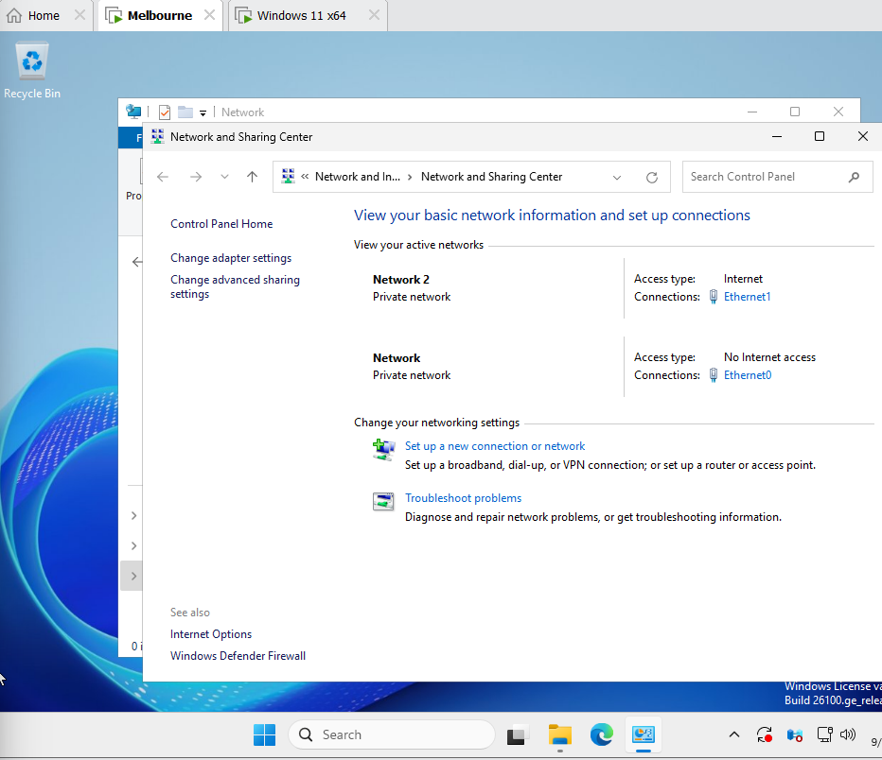
Then go on advanced sharing setting and turn on network discovery and file sharing on private network as it is for current domain.
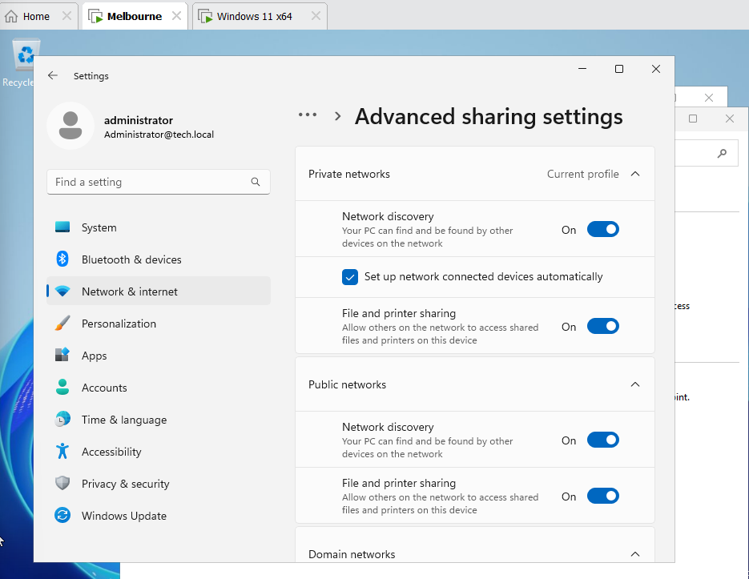
After do the same network discovery setting on user machine, then lets see
Log in same user you give permission lucky smith in my case
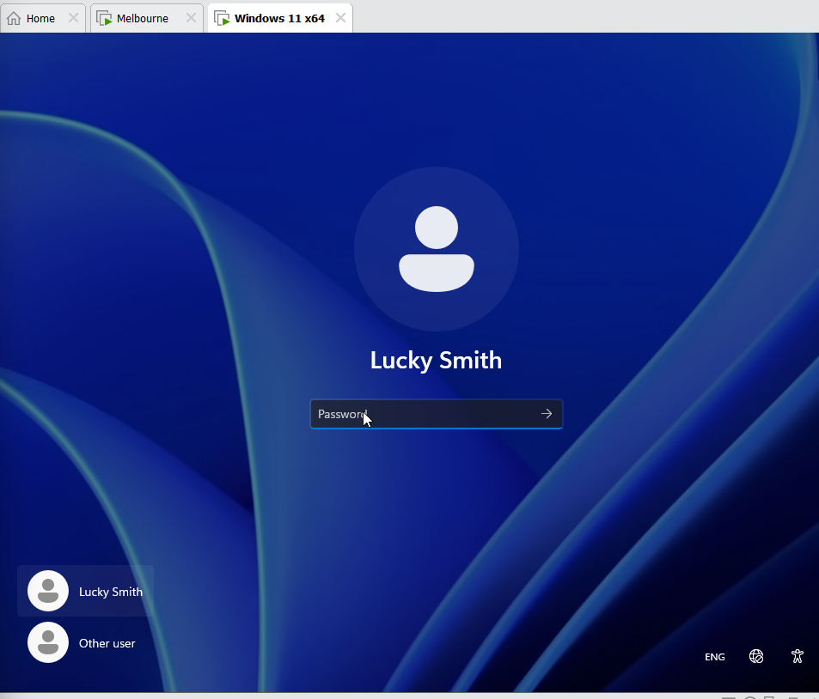

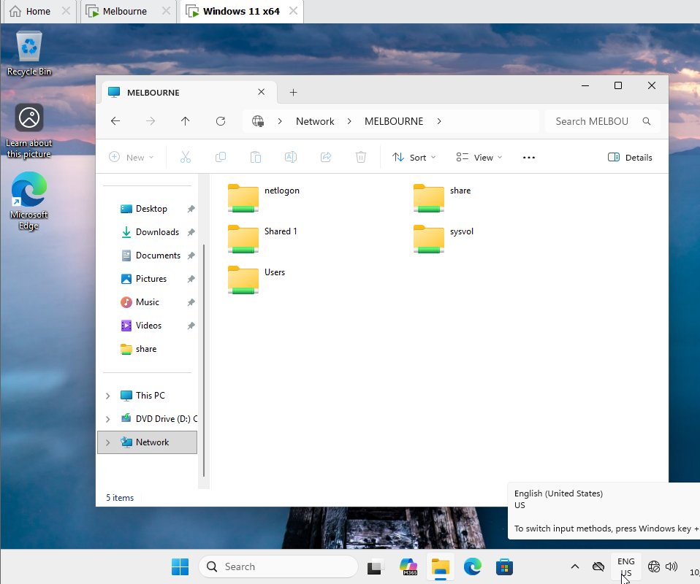
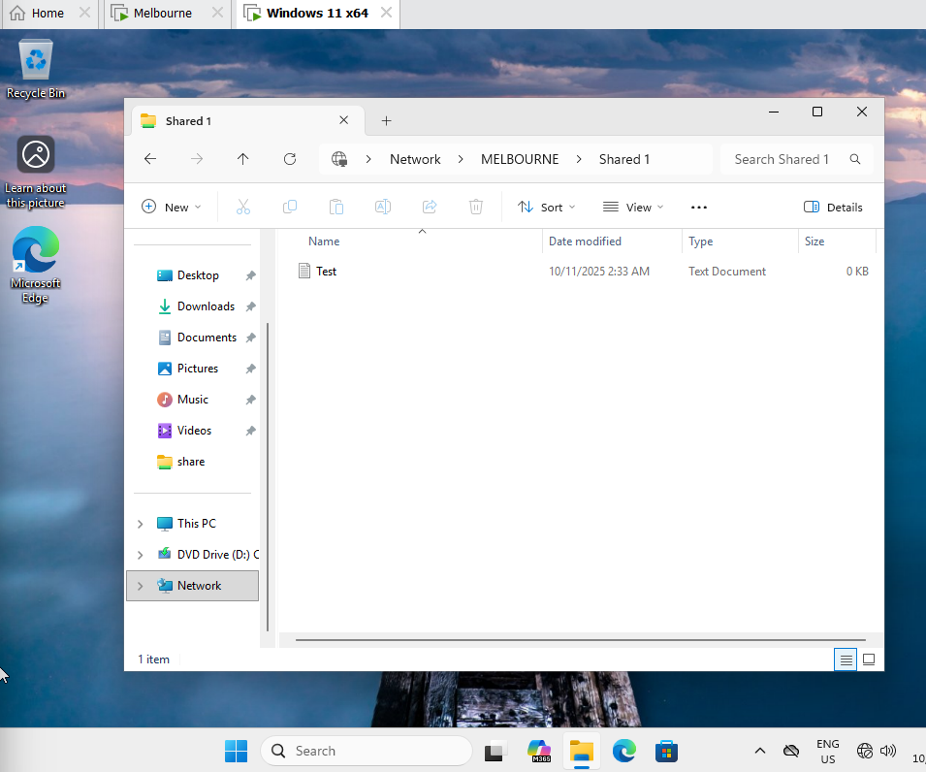
Now lets write inside it
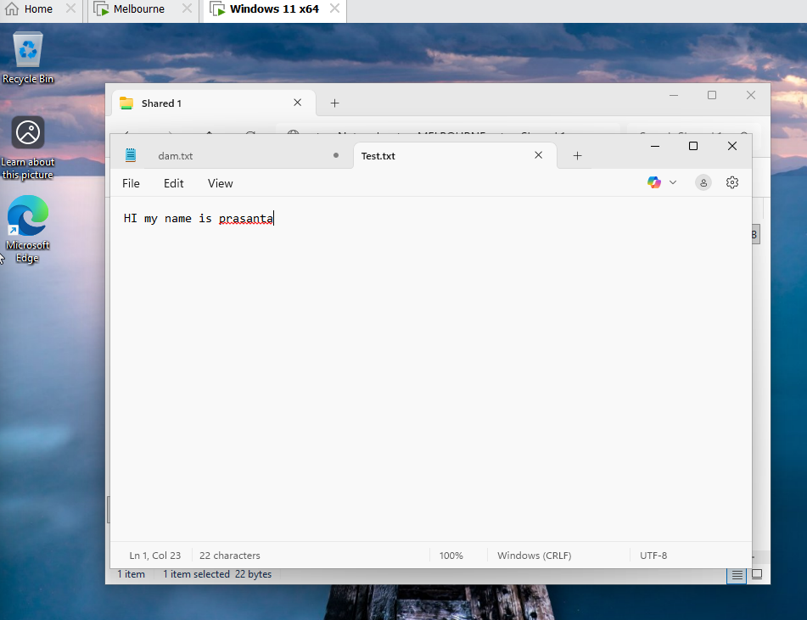
Now check on server
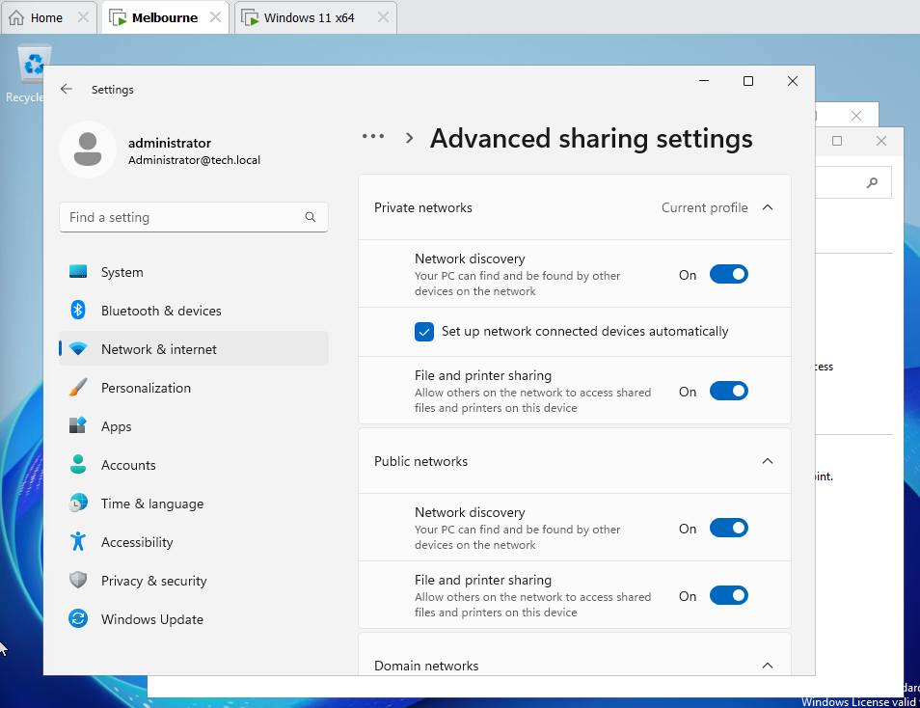
You can see I am on server side now lets navigate the folder where we created shared 1
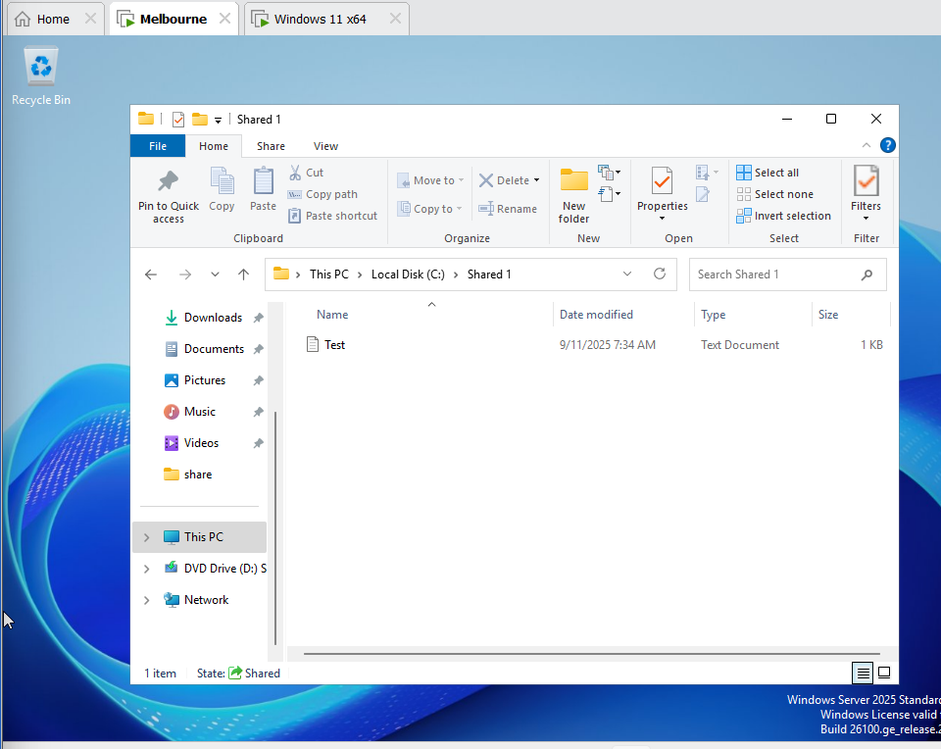
You can see the text document we created on user machine now lets check file inside it
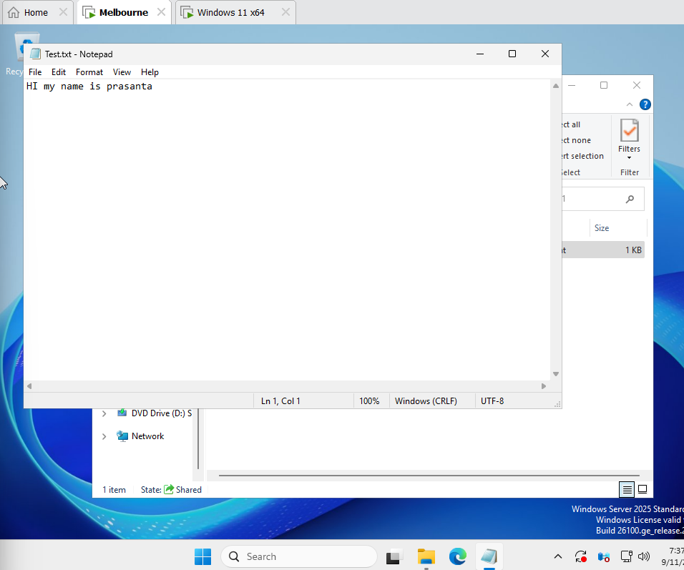
We can see the same text written on server side our folder has been securely shared using full permission.

